/*Ashok IPBC SDLC Agile Methodology Lab 7.11.19*/

Homework – Write a paper on Agile Methodology.

1. What it is?

-AGILE methodology is a practice that promotes **continuous iteration** of development and testing throughout the software development lifecycle of the project. Both development and testing activities are concurrent unlike the Waterfall model.

 it is a process for managing a project characterized by constant iteration and collaboration in order to more fully answer a customer's needs.

The agile software development emphasizes on four core values.

1. Individual and team interactions over processes and tools
2. Working software over comprehensive documentation
3. Customer collaboration over contract negotiation
4. Responding to change over following a plan

The most widely-used Agile methodologies include:

1. Agile Scrum Methodology
2. Lean Software Development
3. Kanban
4. Extreme Programming (XP)
5. Crystal
6. Dynamic Systems Development Method (DSDM)
7. Feature Driven Development (FDD)
8. Explain the process.

The agile process breaks a larger software project into several smaller parts that can be developed in increments and iterations.

Studies have proven that there is a negative correlation between project size and success (i.e.: the shorter the project, the higher the success rate).

The agile approach reduces the size of the project by creating several smaller projects. This iteration approach distinguishes Agile management from other management methods.

Unlike other methods, Agile management uses iterations during the planning and development phases.

Each iteration is usually a 1 to 4 weeks long. During these sessions, the project team and customer team collaborate to prioritize what needs to be added to the iteration.

The final result is a working software program delivered quickly to the customer in a production-like environment.

Customers can then test their program and make changes if needed. Many releases are made throughout the process as changes to the program are made.

A typical iteration process flow can be visualized as follows:

* **Requirements** - Define the requirements for the iteration based on the product backlog, sprint backlog, customer and stakeholder feedback
* **Development** - Design and develop software based on defined requirements
* **Testing** - QA (Quality Assurance) testing, internal and external training, documentation development
* **Delivery** - Integrate and deliver the working iteration into production
* **Feedback** - Accept customer and stakeholder feedback and work it into the requirements of the next iteration

This iteration process is repeated until the project is completed.

1. Why is it used?

IT offers a light framework for assisting teams. It helps them function and maintain focus on rapid delivery. This focus assists organizations in reducing the overall risks associated with software development.

The Agile Method ensures that value is optimized throughout the development process.

The use of iterative planning and feedback results in teams that can continuously align a delivered product that reflects the desired needs of a client.

It easily adapts to changing requirements throughout the process by measuring and evaluating the status of a project. The measuring and evaluating allows accurate and early visibility into the progress of each project.

It could be stated that the Agile Method helps companies build the right product. Instead of trying to market software before it is written, the Agile Method empowers teams to optimize the release during its development.

This allows the product to be as competitive as possible within the marketplace. It preserves the relevance of the critical market, and it ensures that a team’s work doesn’t wind up collecting dust on a shelf. This is why the Agile Method is an attractive developmental option for stakeholders and developers.

1. * 3 Important Facts
2. **Agile is not a methodology:**

It’s a [mindset](http://www.agilemanifesto.org/). Several methodologies are based on the Agile manifesto; two of the most widely known are [Scrum](https://www.scrumalliance.org/) and [SAFe](http://www.scaledagileframework.com/).

1. **A project isn’t Agile just because you use Agile terminology:**

The projects are still defined in terms of requirements, design, configuration, testing and production release—and that isn’t Agile. Agile produces completed products at each iteration, not just at the very end. And in Agile, you build the requirements and design as you go along.

1. **The cost factor:**

The Agile process is less prone to errors and rework because stakeholders are continuously involved. Errors are caught much earlier, long before they result in extensive and expensive rework. However, Agile requires more time commitment from SMEs and stakeholders—not just the product owner. Everyone needs to review work and provide input and feedback during the whole process.

What to Submit:

1. Copy and paste the link to your video(s) as part of your homework.

<https://app.colaberry.com/app/ipbc/videos?user=31221&category=27>

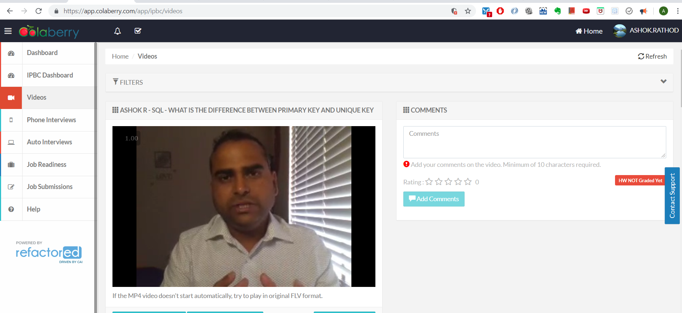

2. Watch, Comment &amp; take screenshots of your comments from 3 other videos on the same

topic (per question). Comments must be 20+ characters. Leave comments based on

presentation, delivery and/or technical details. Your critiques will help you be more

conscious of your own videos. (3 comment screenshots per Video Question)

